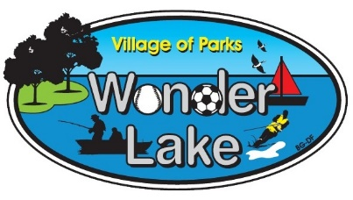
Village of Wonder Lake Water Department
4444 Thompson Road
Wonder Lake, Il. 60097
815-728-0839

The Village of Wonder Lake Water Department is responsible for providing water and sewage treatment (where applicable) according to strict public health guidelines established by the Illinois Environmental Protection Agency (IEPA).

The monthly charge for water services pays for not just the water, but the maintenance and repair of the entire water system. The water system includes an adequate capacity of water supply, water storage, a village wide distribution network of pipe and valves, fire hydrants, maintenance of the existing system, and system expansion to accommodate current and new users.

On an annual basis, the Village evaluates the impact external forces such as inflation and the consumer price index have on operational costs. These costs typically are for treatment chemicals, repair parts, departmental labor, and contracted services. When necessary, water rates are adjusted to account for year-to-year increases in these operational costs.

Because of financial variations related to the long-term economic recovery from the Covid crisis, last year’s CPI increase was 8% which impacted all aspects of operational costs. The water system is an “Enterprise system” which means all water revenue remains in the water department to support departmental operations.

President Dycus’s Message

“The Village of Wonder Lake is finally realizing a period of growth which was initiated nearly 20 years ago. The Meadows of West Bay and Stonewater developments will increase residents within the Village well past levels which require our operations to take considerable steps in providing increased services to our community as well as the staff which make those services possible.

Additionally, we must strive to ensure we are correctly improving our water distribution and sewer capabilities to best service our residents and improve the health of our beautiful lake and its connected downstream systems. Diligent infrastructure management is the result of intelligent planning and building for the future.”

Abraham Lincoln, July 1, 1854
“The legitimate object of government, is to do for a community of people, whatever they need to have done, but can not do, at all, or can not, so well do, for themselves---in their separate, and individual capacities.”

Ongoing Projects

- Woods Creek and Meadows of West Bay Iron Filter Rehab Project
  - Scheduling a meeting with a contractor on site to start the quoting process.
- System Evaluation Report
- Woods Creek Tank Cleaning
- Hydrant Repair Project
- NIU Tower Demolition Project
  - Waiting on contractor’s quote
  - Also include approximately $10,000 in tree cutting to complete the demolition.
- Wooded Shore Watermain Replacement Project
  - Needs approval from the Village to proceed reevaluating.
- Chlorine Analyzer
  - In process
- Well Abandonment
  - McHenry County Permits were signed by the President waiting on scheduling from contractor.

